Shatleh Platform

Al-Zaytoonah University of Jordan  
Faculty of Science and Information Technology  
Department of Software Engineering  
  
Prepared by:  
1- Hussam Khaled  
2- Sadeq Al-sayed Ahmad  
3- Mohammed Ariqat  
4- Mohammed Atiyat  
  
Supervisor: Dr. Wael Zyadat  
Second Semester 2024/2025

# ABSTRACT

Shatleh is an online agricultural platform designed for a company that connects suppliers, agricultural engineers, and customers in one place.   
The platform displays agricultural products. When a customer places an order, the company buys the items, the company does not have a stock it depends on collaboration between the company and the agricultural shops. Additionally, Shatleh offers agricultural services through a team of expert engineers. The platform also provides educational agricultural content via blog posts.   
This project uses the gap that is in the agricultural market and solves the problem of scattered agricultural services and aims to bring all customer needs into one platform in Arabic.

# 1. Introduction

## 1.1 Project Description

Shatleh is an online agricultural platform that serves as a digital marketplace and service provider. It allows a company to list products from different suppliers without buying them first. The company earns profit by buying the products at wholesale prices when an order is placed, then delivering them to the customer.  
The platform includes services offered by agricultural engineers.  
It also features educational content shared regularly by the agricultural team.  
Our goal is to deliver a complete agricultural solution for users, helping them find everything in one trusted platform.

## 1.2 Project Overview

The platform addresses a gap in Jordan’s agricultural ecosystem by offering a trusted, centralized, and scalable solution that provides products, services, and educational content with government support and engineering expertise.

## 1.3 Tasks

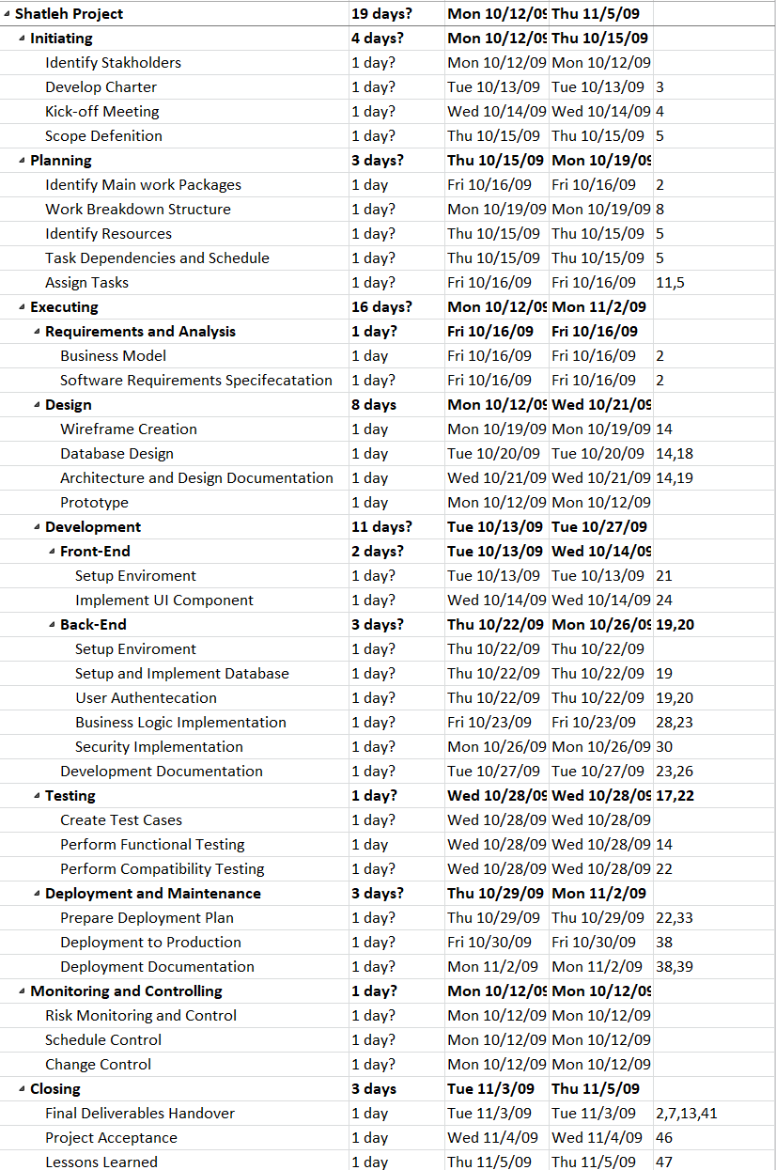

## 1.4 Project Planning

The project is divided into multiple phases including Requirement and Analysis, Design, Development, Testing and Deployment. Each phase is allocated specific time and tasks.

## 1.5 Planning of the Development Phases

* Requirement and Analysis → March
* Design → March–April
* Development → April–May
* Testing → Late May
* Deployment → Jun

## 1.6 The Scope of the Work

This documentation covers technical, business, and functional aspects of the Shatleh Platform, which targets both agriculture consumers and professionals.

## 1.7 Stakeholders

The stakeholders include customers, suppliers, agricultural engineers, and the platform administrators.

**1.7.1 Customers**

|  |  |
| --- | --- |
| **Description** | Individuals who purchase agricultural products and services for personal use. |
| **Type** | External, End-user |
| **Responsibilities** | Browse and purchase products/services. Provide feedback through reviews and ratings. Engage with experts for consultations. |
| **Success Criteria** | High customer satisfaction and repeat purchases. Positive user experience and engagement. Low cart abandonment rate. |
| **Involvement** | Actively participates in user testing, provides feedback on usability, suggests new features or improvements, and contributes to community discussions. |
| **Deliverables** | Orders placed and completed. Reviews and feedback provided. |
| **Comments / Issues** | User experience and trust in product quality are critical. Need for an easy-to-use interface and responsive customer support. |

**1.7.2 Government and Agricultural Organizations**

|  |  |
| --- | --- |
| **Description** | Regulatory bodies, government agencies, and nonprofit organizations ensuring compliance and supporting sustainable agriculture. |
| **Type** | External, Regulatory & Support |
| **Responsibilities** | Ensure platform compliance with agricultural standards. Provide support or incentives for digital agriculture solutions. Promote sustainable farming initiatives. |
| **Success Criteria** | Compliance with legal and agricultural regulations. Effective partnerships for agricultural development. Increased adoption of sustainable practices. |
| **Involvement** | Medium (oversight and support). |
| **Deliverables** | Regulatory approvals. Funding or incentives for agricultural initiatives. |
| **Comments / Issues** | Changing regulations could impact platform operations. Need for ongoing communication to ensure compliance. |

**1.7.3 Developers (Software Engineers & IT Team)**

|  |  |
| --- | --- |
| **Description** | The technical team responsible for building, maintaining, and enhancing the platform. |
| **Type** | Internal, Technical |
| **Responsibilities** | Develop and maintain the platform’s web and mobile applications. Ensure security, scalability, and performance optimization. Implement new features and integrations based on user feedback. |
| **Success Criteria** | Success is defined by delivering a robust, scalable, and user-friendly platform that meets stakeholder requirements and expectations. Rewarded for meeting project milestones and achieving high-quality code standards. |
| **Involvement** | Actively participates in all stages of the project, including requirements gathering, design discussions, development sprints, testing, and deployment. |
| **Deliverables** | Codebase, system documentation, technical specifications, and user interface designs. Bug fixes and performance enhancements. |
| **Comments / Issues** | Limited resources or time constraints may impact the speed of development and quality of deliverables. Communication and collaboration with other stakeholders are essential for project success. Balancing new features with platform stability. |

**1.7.4 Agricultural Suppliers and Partners**

|  |  |
| --- | --- |
| **Description** | Vendors and service providers supplying agricultural products and services. |
| **Type** | External, Business Partner |
| **Responsibilities** | Reliable and diverse product offerings. High customer satisfaction with products. Stable business relationships with the platform. |
| **Success Criteria** | Reliable and diverse product offerings. High customer satisfaction with products. Stable business relationships with the platform. |
| **Involvement** | High (core to platform operations). |
| **Deliverables** | Product inventory and updates. Order fulfillment and tracking. |
| **Comments / Issues** | Managing supply chain disruptions. Need for efficient logistics and delivery solutions. |

**1.7.5 Investors and Business Partners**

|  |  |
| --- | --- |
| **Description** | Private sector entities and businesses funding or collaborating with the platform. |
| **Type** | External, Financial & Strategic Partner |
| **Responsibilities** | Provide financial investments for growth. Offer strategic business insights. Support expansion into new markets. |
| **Success Criteria** | Positive return on investment (ROI). Growth in user base and revenue. Sustainable and scalable business model. |
| **Involvement** | Medium to High (depending on investment level). |
| **Deliverables** | Financial contributions and funding rounds. Business development strategies. |
| **Comments / Issues** | Investor expectations may shape platform decisions. Potential risks in financial dependency. |

**1.7.6 Technology Providers**

|  |  |
| --- | --- |
| **Description** | Companies offering cloud services and payment processing (stripe). |
| **Type** | External, Technical Partner |
| **Responsibilities** | Ensure platform infrastructure and availability. Provide secure payment processing and data encryption. |
| **Success Criteria** | Platform uptime and minimal downtime. Smooth integration with third-party services |
| **Involvement** | Medium to High (depending on investment level). |
| **Deliverables** | Hosting and cloud infrastructure solutions. Secure payment. |
| **Comments / Issues** | Dependence on external service providers. |

**1.7.7 Employees (Including Agricultural Experts & Customer Support)**

|  |  |
| --- | --- |
| **Description** | Platform staff responsible for managing orders, providing agricultural consultations, and assisting customers. |
| **Type** | Internal, Operations & Service Provider |
| **Responsibilities** | Process and manage customer orders. Provide expert agricultural consultations. Handle service bookings and track fulfillment. Assist customers in selecting the right products/services. Provide customer support and resolve issues. |
| **Success Criteria** | High order fulfillment rate. Positive customer ratings and feedback. Effective problem resolution for customers. High engagement in consultation services. |
| **Involvement** | High (day-to-day operations & consultations). |
| **Deliverables** | Processed and completed orders. Consultation sessions conducted. Customer support tickets resolved. |
| **Comments / Issues** | Managing workload between operational tasks and expert consultations. Ensuring timely updates on pending consultation requests. High demand during peak seasons may require more resources. |

**1.7.8 Administrators**

|  |  |
| --- | --- |
| **Description** | Oversee platform operations, user management, and policy enforcement. |
| **Type** | Internal, Management |
| **Responsibilities** | Approve and manage product listings. Oversee experts, employees, and suppliers. Monitor platform performance and security. |
| **Success Criteria** | Efficient platform governance. High-quality service and product offerings. Secure transactions and data protection. |
| **Involvement** | High (ongoing management). |
| **Deliverables** | Platform reports and analytics. Policy enforcement and user moderation. |
| **Comments / Issues** | Need for effective user and content management tools**. |

## 1.8 Scope

The platform is limited to agricultural products, services and educational content in the beginning, with a potential to scale in the future.

## 1.9 Definitions, Acronyms, and Abbreviations

Shatleh: The name of the platform.  
B2B: Business to Business.  
B2C: Business to Customer.

## 1.10 References

None. All content is original.

## 1.11 Overview

This document presents the full vision, requirements, design, and planning for the Shatleh graduation project.

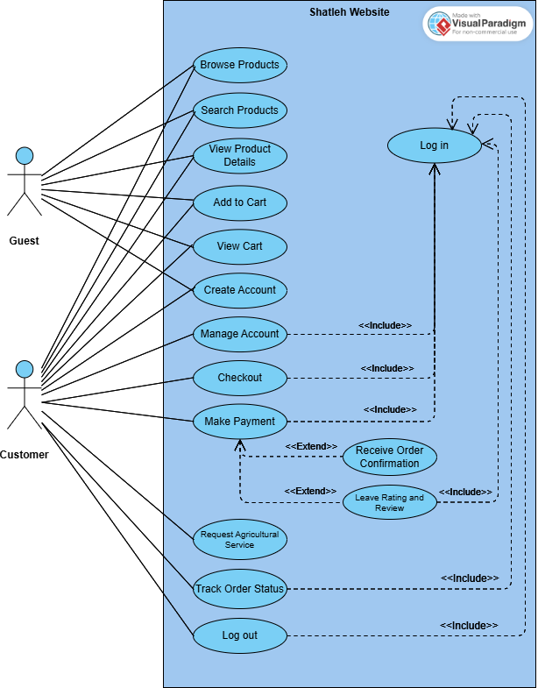

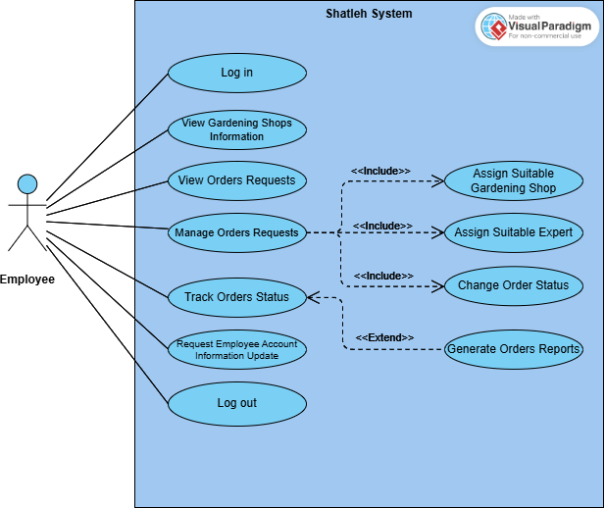

# 2. Positioning

## 2.1 Business Opportunity

There is a growing interest in agriculture and home gardening.   
However, people often struggle to find trusted sources for plants, tools, and expert guidance. Shatleh offers a complete solution in one place, making it easy for customers to order products and request services online.

## 2.2 Problem Statement

The problem of scattered agricultural services and products affects customers who want to find everything they need in one place.  
The impact of this is wasted time, poor product quality, and lack of guidance. A successful solution would be an online platform that provides trusted products, expert services, and helpful information in one place.

## 2.3 Product Position Statement

For individuals interested in agriculture and home gardening,  
Who need a simple way to get products and expert services,  
Shatleh is an online agricultural platform  
That offers trusted products, professional services, and educational content.  
Unlike visiting many different stores or websites,  
Our platform combines everything in one place with expert quality control.

# 3. Stakeholder and User Descriptions

## 3.1 Market Demographics

Target users include home gardeners, small farm owners, plant lovers, and anyone interested in agricultural services.  
The market is growing due to trends like sustainability, home decor with plants, and interest in organic products.

## 3.2 Stakeholder Summary

|  |  |  |
| --- | --- | --- |
| Name | Description | Responsibilities |
| Customers | Individuals and businesses purchasing agricultural products and services. | - Browse and purchase products.  - Request expert consultations.  - Provide feedback and reviews.- read educational content and interact with it. |
| Employees (Including Experts) ** | Staff responsible for platform operations, order management, customer support, and expert consultations. | - Handle order processing.  - Support customers with inquiries.  - Provide expert consultations and advice.  - Manage supplier interactions. |
| Administrators | System managers overseeing platform operations and ensuring efficiency. | - Monitor platform performance.  - Approve and manage employees.  - Handle transactions and policies. |
| Agricultural Suppliers | |  | | --- | | Vendors and businessesproviding agricultural productslisted on the platform. | | - Supply and update product inventory.  - Manage stock availability.  - Ensure product quality. |
| Government and Agricultural Organizations | Regulatory bodies ensuring compliance with agricultural standards and laws. | - Provide legal guidelines and compliance oversight.  - Support sustainable farming initiatives.  - Offer potential funding or incentives. |
| Investors and Business Partners | |  | | --- | | Private entities interested in fundingand collaborating on platformgrowth. |  |  | | --- | |  | | - Provide financial backing.  - Assist in business strategy development.  - Partner for logistics and expansion. |
| Technology Providers | Companies providing cloud hosting, payment gateways, and security solutions. | - Ensure platform scalability and security.  - Provide secure payment solutions.  - Maintain technical infrastructure. |
| Developers and Designers | Engineers and designers responsible for building and maintaining the platform. | - Develop and optimize platform features.  - Improve user experience and interface.  - Ensure system security and performance. |

## 3.3 User Summary

|  |  |  |  |
| --- | --- | --- | --- |
| Name | Description | Responsibilities | Stakeholder |
| Home Gardeners | Individuals interested in small-scale gardening and plant care. | - Purchase gardening products.  - Seek expert guidance on plant care.  - Engage in discussions and reviews. | Customers |
| Farmers | Small to mid-sized agricultural producers seeking supplies and services. | - Purchase farming essentials.  - Consult experts on agricultural practices.  - Manage bulk orders and logistics. | |  | | --- | | Customers |  |  | | --- | |  | |
| Retailers & Businesses | Businesses looking for bulk agricultural supplies and partnerships. | - Order large-scale agricultural products.  - Collaborate with suppliers and vendors.  - Explore technology integration for farming. | Customers |
| Platform Administrators | Individuals managing platform governance, policies, and overall functionality. | - Approve vendors and employees.  - Monitor user activity and engagement.  - Ensure compliance with industry standards. | Employees |
| Environmental Advocates | Advocates for sustainable practices, supporting initiatives such as book exchanges as alternatives to purchasing new books. | - Support sustainable consumption practices.- Monitor environmental impact of book consumption. | Administrators |
| IT Support & Developers | Technical team ensuring smooth operation, security, and updates of the platform. | - Maintain system security.  - Optimize platform performance.  - Fix bugs and introduce new features. | Developers and Designers |

## 3.4 User Environment

Users access the system via web browsers on laptops or mobile phones.   
The platform will be optimized for ease of use, with a clean interface for browsing products, booking services, and reading posts.

## 3.5 Stakeholder Profiles

Stakeholder: Expert, Employee.  
Type: Business  
Responsibilities: Provide product data, prepare orders.  
Involvement: External data providers.  
Success Criteria: More sales via the platform.

## 3.6 User Profiles

User: Customer  
Type: Casual user  
Responsibilities: Browse, order, request services.  
Success Criteria: Easy, successful orders and helpful support.

## 3.7 Key Stakeholder or User Needs

## • Customers – Individuals and businesses purchasing agricultural products and services. • Employees (Including Experts) – Staff responsible for order management, customer support, and expert consultations. • Administrators – System managers overseeing platform operations and ensuring efficiency. • Agricultural Suppliers – Vendors and businesses providing agricultural products listed on the platform. • Government and Agricultural Organizations – Regulatory bodies ensuring compliance with agricultural standards and laws. • Investors and Business Partners – Private entities interested in funding and collaborating on platform growth. • Technology Providers – Companies providing cloud hosting, payment gateways, and security solutions. • Developers and Designers – Engineers and designers responsible for building and maintaining the platform

## 3.8 Alternatives and Competition

- Facebook Marketplaces: Unorganized, no quality control.  
- Local Nurseries: No online access.  
Shatleh offers better structure, expert support, and educational content.

# 4. Product Overview

## 4.1 Product Perspective

The platform is a standalone web application with a backend (Laravel) and frontend (React).

## 4.2 Summary of Capabilities

- Display agricultural products from suppliers.  
- Handle customer orders and payments.  
- Allow booking of agricultural services.  
- Post and manage educational content.  
- User registration and secure login.  
- Admin control panel to manage users and content.

## 4.3 Assumptions and Dependencies

The project depends on internet access and support from suppliers and engineers.

## 4.4 Cost and Pricing

The platform is a student project. No real pricing is involved yet, but the idea includes profit from product margins and service fees.

## 4.5 Licensing and Installation

Open-source libraries and frameworks are used. The system will be hosted on a web server after development.

To be continued 😊

# 5. Product Features

- Product Browsing  
- Shopping Cart & Orders  
- Service Booking  
- Blog for Educational Content  
- User Profiles  
- Admin Dashboard

# 6. Constraints

The project must be completed in 3 months. Limited resources and testing environments.

# 7. Quality Ranges

The system must be easy to use, responsive, and reliable.

# 8. Precedence and Priority

Main features like ordering and booking services have top priority.

# 9. Other Product Requirements

## 9.1 Applicable Standards

Follows common web development standards and best practices.

## 9.2 System Requirements

Web browser, internet connection, Laravel backend server, and React-compatible frontend environment.

## 9.3 Performance Requirements

System should load pages in under 2 seconds and handle up to 100 concurrent users.

## 9.4 Environmental Requirements

Designed for use on desktop and mobile browsers in normal environments.

# 10. Documentation Requirements

## 10.1 User Manual

A simple manual showing how to browse, order, book services, and read posts.

## 10.2 Online Help

FAQ section and contact support page.

## 10.3 Installation Guides, Configuration, and Read Me File

Installation guide includes Laravel and React setup steps.

## 10.4 Labeling and Packaging

No physical packaging. All online. Project includes branding assets like logo and icons.

# Appendix A: Feature Attributes

Status: Proposed  
Benefit: Critical  
Effort: Medium  
Risk: Low  
Stability: Medium  
Target Release: Final project  
Assigned To: Team Members  
Reason: Graduation Project